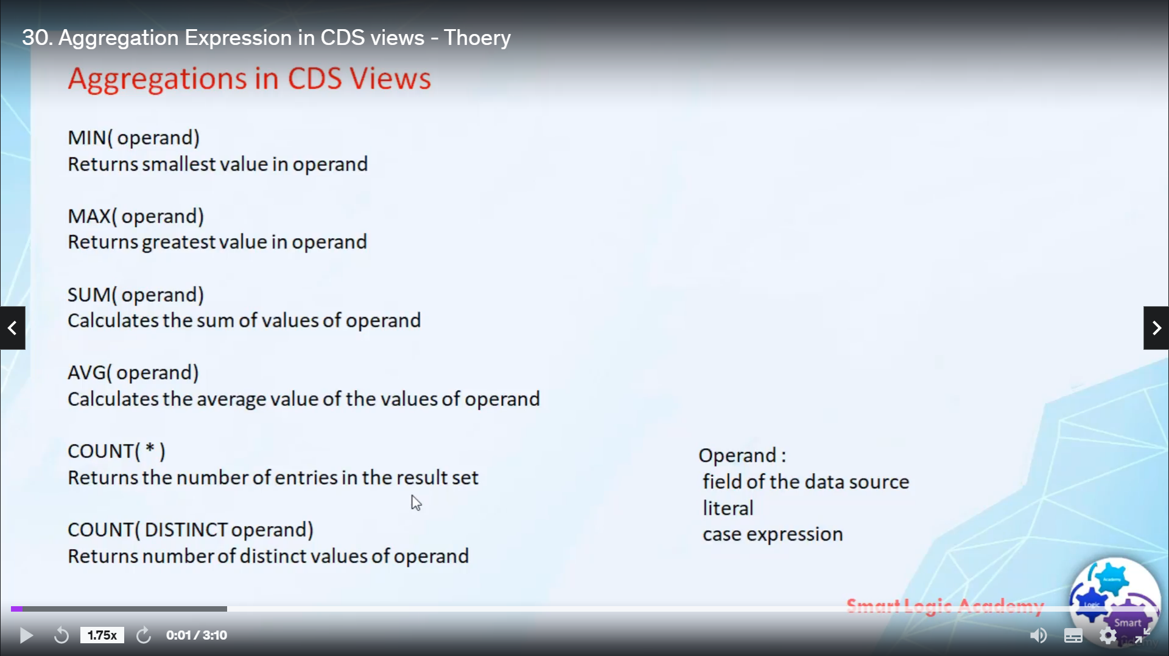

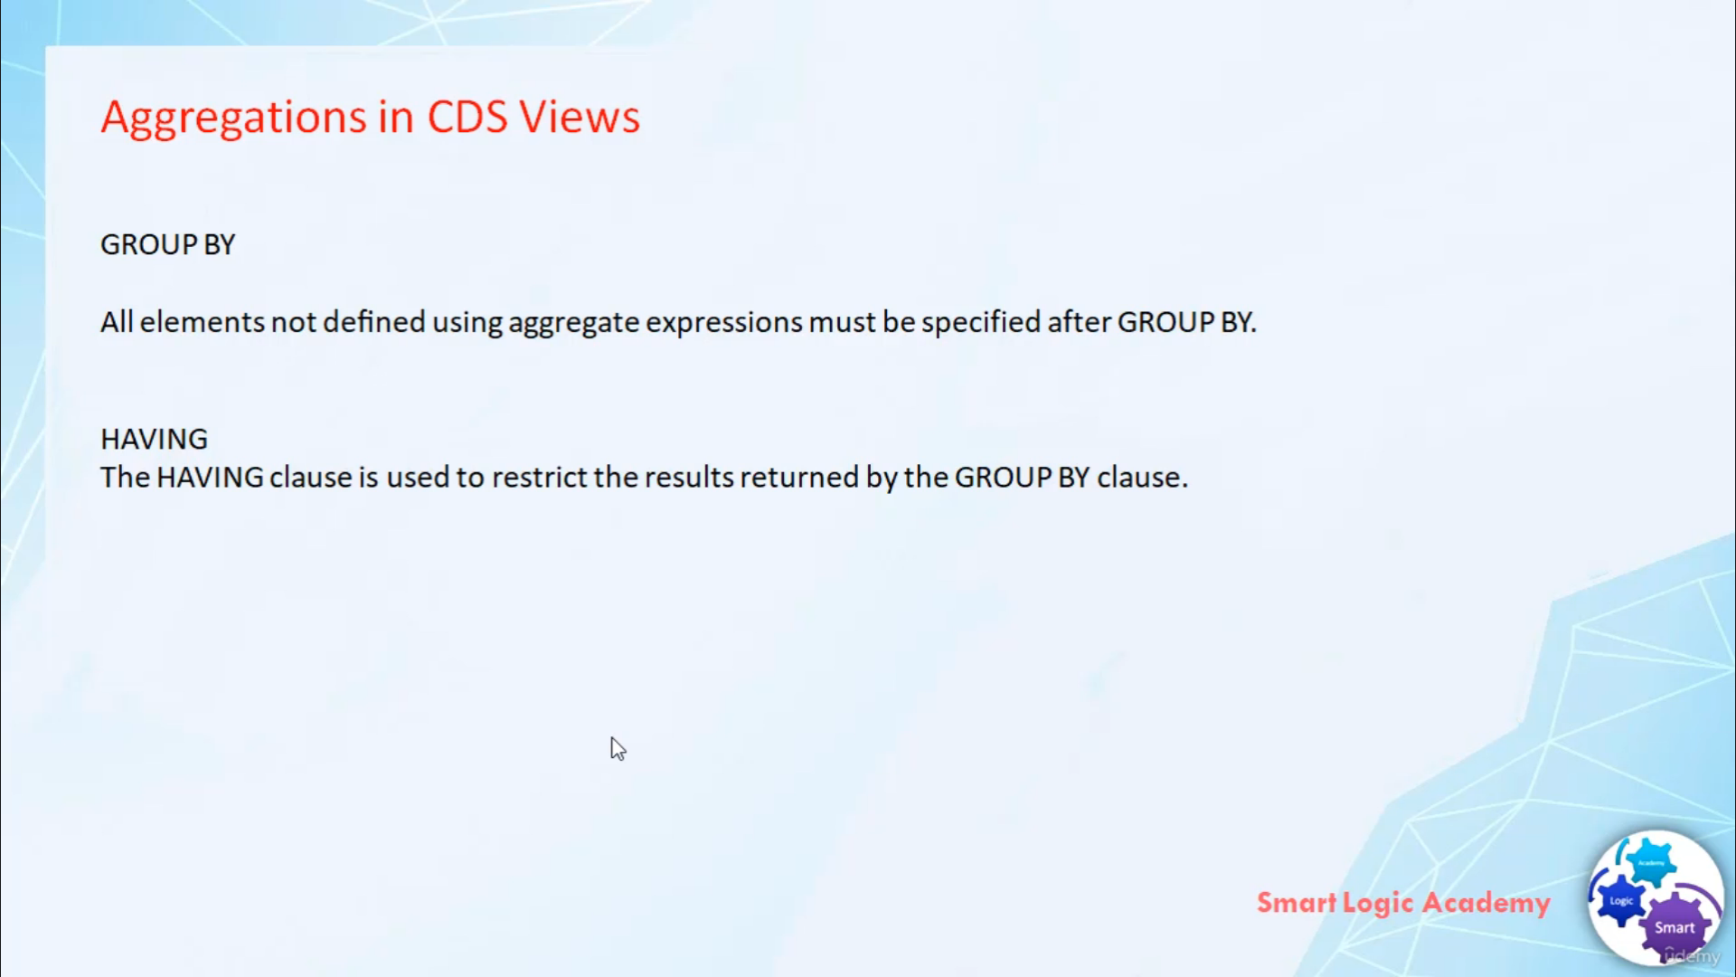

Hi, welcome back.

In this video, I will discuss with you about the allegations in Arbitrageurs, we will quickly go to

the details related to allegations in absurdism and then we will create one this view where we will

try to use all the aggregate information that we have learned.

So let's start the first aggregation function is mean these returns the smallest value in operand.

Your operation can be a field of datasource.

It can be a leader or it can be a expression.

Second aggregation question is, Max, it returns the greatest value in offering some it calculates

the sum of values of operand average.

It calculates the average value of the values of operand count.

It returns the number of interesting results it.

Distinct, it retains of distinctive values of operand.

An aggregation explosion always calculates a single value from an open.

You can use aggregation expressions in the list of select statement audin having clothes.

If you are using a lesion function in the felicitously statement that is become mandatory to provide

an alias, one more point you have to remember, because when you use Alridge aggregation, the return

type of result is always fluting.

When you use Min Max or some segregation's, then the return type is always the same as operand type.

And when you use the aggregation code and congesting it always returns integer value.

Whenever we create an view with aggregations, the commonly used with group, but having.

A Christian group by a group, those rules in the ResultSet that have the same content in the elements

specified by free as a single group.

Whenever you use the aggregation function in our we'll make sure that gloopy must be used if aggregate

expressions are contained in the select list and all the elements are not defined, using aggregation,

expressions must be specified after group by.

Having the having clauses used to refer to the result written by a group by clause, so it's like you're

putting their conditions on reserve, take them by group by.